**BLOOD DONATION WEBSITE**

END TERM PROJECT

***By-***

**NAME OF THE CANDIDATE(S)**- Roll Number(s)

1. Akash Kumar 02
2. Sai Srujan 03
3. Surya Kalyan Reddy 04

Section: K19JC



**Student Declaration**

This is to declare that this report has been written by us. No part of the report is copied from other sources. All information included from other sources have been duly acknowledged. We will take full responsibility, if any content of our page found to be copied from any source.

Akash Kumar

Roll Number: 02

Sai Srujan

Roll Number: 03

Surya Kalyan Reddy

Roll Number: 04

**TITLE**

1. Introduction

2. Objective

3. Description of project

4. Description of work division

5. Implementation

6. Technologies and framework

7. SWOT analysis

**BONAFIDE CERTIFICATE**

This is to Certify that this final report of topic "DESIGNING OF

BLOOD DONATION WEBSITE" is the bonafide work of

“AKASH KUMAR, SAI SRUJAN and SURYA KALYAN REDDY"

who carried out the project work Under my supervision.

KUNJ MARKEN

Department of Intelligent

System

**INTRODUCTION**

This blood donation online website has been created because

of many People who don’t know about it, in order to create

awareness among the People. And also, to provide information

to those who want to seek to Donate blood but don’t have proper

knowledge that where they should go or what sort of

requirements are needed and what are the thing we have

To do before blood donation and after donation.

As we all know that every drop of blood is so much valuable

It can save lives of those who are in need, so in order to help them

We all should donate website.

Our website consists of many features where you can get all sort of

information that you are seeking to get. You can search for places

where active camps are being organized for blood donation, and

other things that why we should donate blood and many other

information has been made available.

**OBJECTIVE OF WEBSITE DESIGNING**

Our main objective of website designing is to make sure that every

one should can get knowledge about blood donation, its importance

and why one should donate blood.

Our website has been made using html, CSS and java script which

Keep the record of who want to donate the blood where they can

Donate blood, also about the active blood donation camps, and the

Main moto is to keep all the records online instead of manual

Method, so it is much much easy to access to these things online.

Our website not just only designed to keep record but it also shows

Where user can donate blood.

It also allows you to refer a friend option so if any of your friend

Who is seeking to donate blood so you can refer him that

He can donate blood and if he is interested than he can

Register for blood donation by registering himself using

Our register options.

**DESCRIPTION OF PROJECT**

There’s no end to the benefits of donating blood for those who need it. According to the [American Red Cross](https://www.redcrossblood.org/donate-blood/how-to-donate/how-blood-donations-help/blood-needs-blood-supply.html), one donation can save as many as three lives, and someone in the United States needs blood every two seconds.

It turns out that donating blood doesn’t just benefit recipients. There are health benefits for donors, too, on top of the benefits that come from helping others. Read on to learn the health benefits of donating blood and the reasons behind them.

Blood donation is safe for healthy adults. There’s no risk of contracting disease. New, sterile equipment is used for each donor.

Some people may feel nauseous, lightheaded, or dizzy after donating blood. If this happens, it should only last a few minutes. You can lie down with your feet up at the until you feel better.

You may also experience some bleeding at the site of the needle. Applying pressure and raising your arm for a couple of minutes will usually stop this. You may develop a bruise at the site.

**DESCRIPTION OF WORK DIVISION**

dddWe have divided our work into 3 steps, which are as follows-

**step 1-** first step include making of our homepage. With the help ____of html

**+++**and CSS. In our home page we have given all sorts of option that cccare already visible in the screenshot of our home page. It cccconsist of register button through which one can register him ddf for blood donation, next is why one should donate blood where the person who seeking for knowledge can go and learn why he or ddddshe should donate blood and next is refer a friend where if dddanyone in your surrounding is seeking to donate blood than you can refer him and then contact us where you can contact us if you ddddhave any queries regarding blood donation or any other.

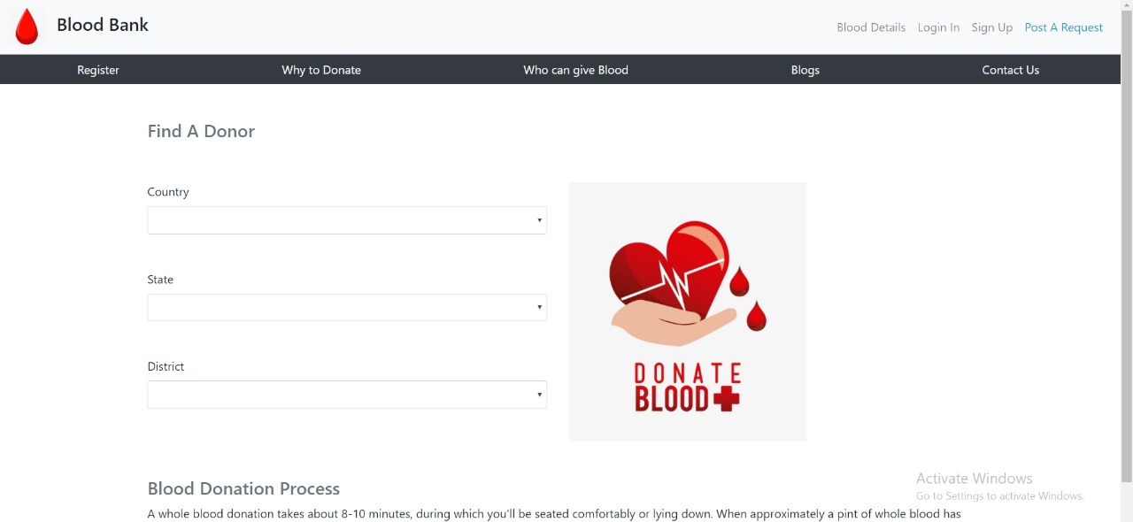

**Step-2:** then our step 2 is to design all the other pages which our related to

our home page, which includes all the options which we have mentioned earlier like, register, why we should donate blood, who can donate blood, refer a

friend, and contact us option.

Our all the other pages consist of all the other requirements that are necessary to keep.

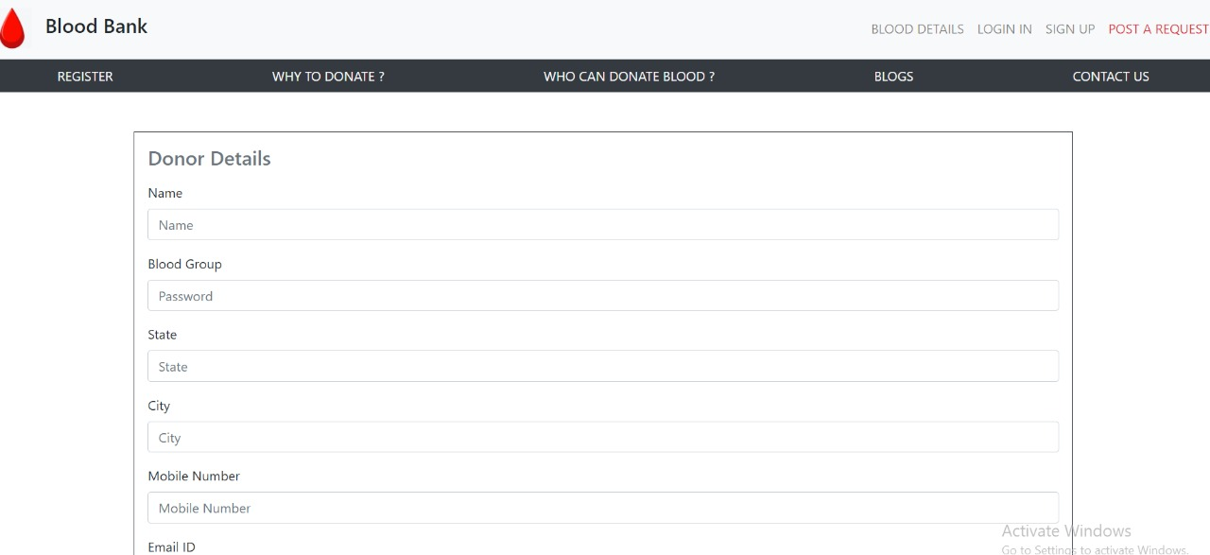

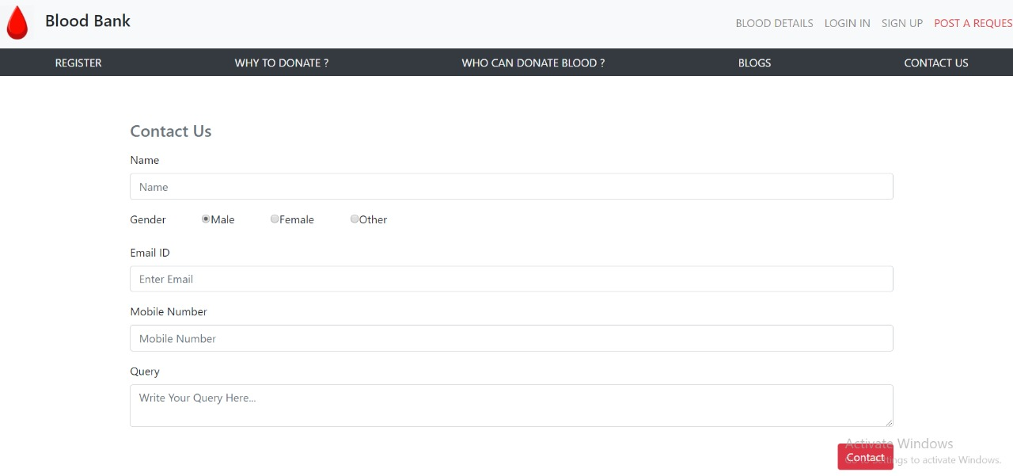

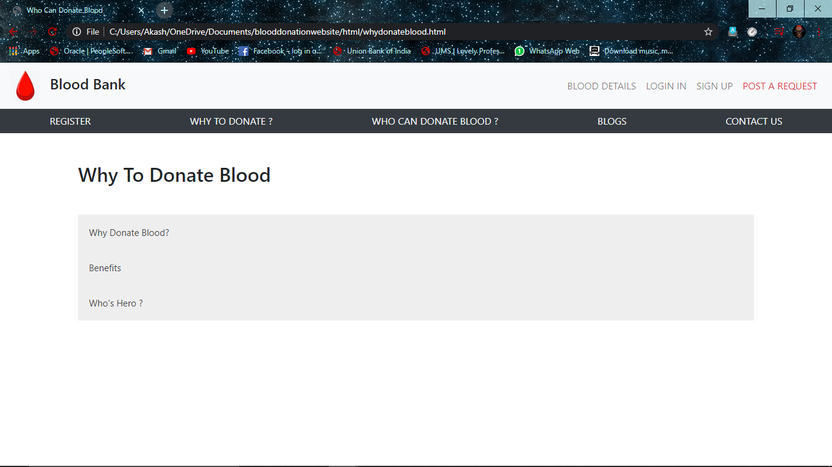

**Step 3:** our step 3 includes decorations of our webpages with the help of CSS. we have tried to make our web pages look beautiful. So, if any one comes to see our page then not only because of knowledge but also because of beauties of our page he should stay on page.

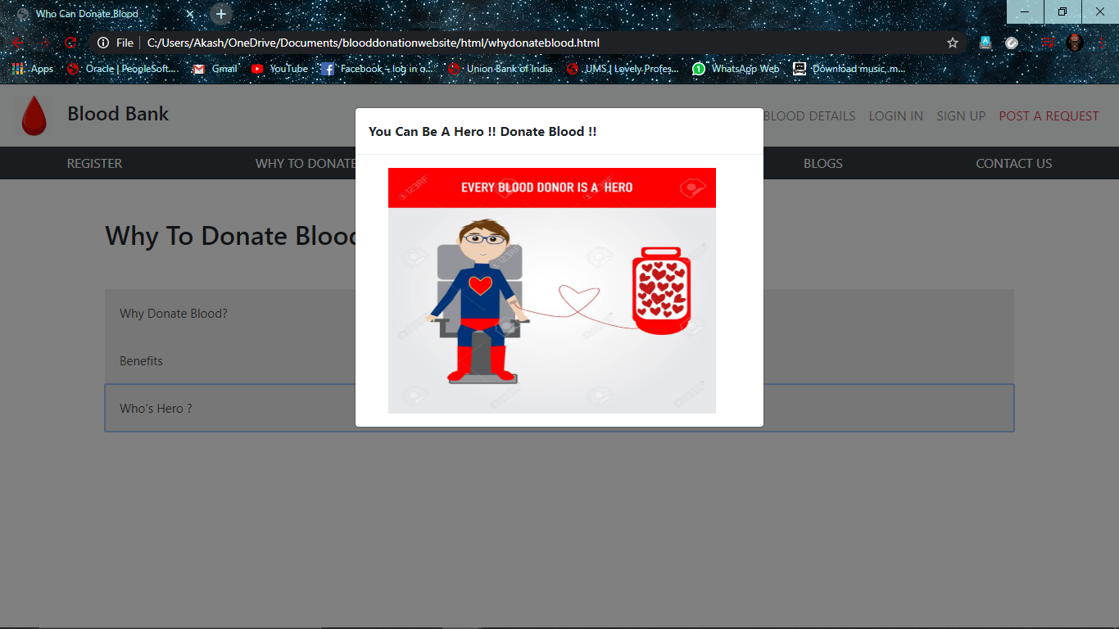

**IMPLEMENTATION**

An overview:

* **HTML**works as a structure of a webpage. It provides a basic design which can be enhanced with the help of CSS and java script.
* **CSS** is used for decoration and controlling of further tokens.
* **JavaScript** is used to control further operation and to make our webpage functionality more improved

Html:

* 1. **Website Accessibility** - Validating your HTML code helps pinpoint potential roadblocks that could prevent search engine spiders or visitors from accessing your entire site.
* 2. **Faster Loading** - Removing unneeded code can help create smaller pages which intern helps your website load faster. Faster loading provides a better customer experience and can help with search engine rankings.
* 3. **Less load on servers** - Clean code will not tax your server as much. This cuts down on the amount of Web space and bandwidth used and can reduce the cost of hosting your site.

CSS:

* Easier to maintain.
* Easy way for decoration.
* Also provide upper structure to our webpage.
* Can be changed or enhanced easily

**FRAMEWORK**

**PROJECT TITLE: BLOOD DONATION**

**PROJECT DESCRIPTION:**

Blood Donation site contains information about the number of blood banks and applicants willing to Donate blood.

It covers the following modules:

##### Register, Why to donate blood, who can give blood, Refer a friend, Contact us

For the framework and reference of our website, we as a team stick to the module and frame of reference given by our faculty and worked on our website accordingly with some required modification where there was a need or in order to make the look of the website and design more put-together.

Here we have attached an image which we used as our framework-

**SWOT ANALYSIS**

S: 1. Seeker can get blood easily.

2. and also a person can search here for the blood group which he needs.

3. and the person who want to donate can search for the active blood camps for donating blood.

W: 1. It requires an internet

2. Back-end is not their

O: 1.got able to know more about CSS and java

2. also how to implement

T: 1. Website designing has been completed succefully and also working.

